IST 769 – Advanced Big Data Management

Research Project

Topic: Amazon DynamoDB

Karan Bharadwaj: 266252923

Thejaswini Ram: 311599390

School of Information Studies, Syracuse University

Prof. Michael Fudge

**DynamoDB Overview**

Amazon DynamoDB is a fully managed proprietary NoSQL database service that is provided by Amazon.com as part of the Amazon Web Services portfolio. It supports key–value and document data structures. On January 18, 2012, Amazon CTO Werner Vogels unveiled DynamoDB as a successor to Amazon SimpleDB.

With horizontal scaling, it can accommodate tables of nearly any size. Over petabytes of storage, DynamoDB can expand to more than 10 trillion requests per day, with peaks of more than 20 million requests per second. **Both key-value and document data models are supported by DynamoDB.** This allows DynamoDB to have a flexible schema, which means that each row can contain any number of columns at any time. This allows us to simply alter the tables when our business needs change, rather than having to rewrite the table schema as we would with relational databases.

DynamoDB allows developers to create modern, serverless apps that scale globally to support petabytes of data and tens of millions of read and write requests per second. DynamoDB is built to run high-performance, internet-scale applications that might otherwise overwhelm standard relational databases.

There are no servers to deploy, patch, or manage, and no software to install, maintain, or run while using DynamoDB. DynamoDB scales tables dynamically to compensate for capacity and maintains performance with no manual intervention. Availability and fault tolerance are built-in, so we won't have to worry about architecting our applications to accommodate these features. DynamoDB is designed for mission-critical workloads, including atomicity, consistency, isolation, and durability (ACID) transactions for a wide range of applications with complex business logic. DynamoDB helps protect your data by encrypting it and backing it up on a regular basis, all with guaranteed dependability thanks to a service level agreement.

**Key Features**

DynamoDB is a highly available, fully managed NoSQL database. So, it's not a relational database, but it's a NoSQL database. It is fully distributed and scales to enormous workloads. Regardless of the workload, can expand to millions of requests per second, trillions of rows, and hundreds of terabytes of storage. There is a really reduced latency on retrieval because of the rapid and constant performance. It's fully connected with IAM for security, authorization, and management because it's a service. It is low-cost and has the ability to scale automatically.

DynamoDB organizes data into tables, each of which contains many items (rows), each of which has its own set of Keys and Attributes (columns). The tables in DynamoDB are not relational and do not follow a schema. This means that table joins aren't possible at the database level. We don't need table joins in most circumstances, and those work well with DynamoDB.

**DynamoDB terminology:**

1. Tables: We specify a Partition Key and an optional Sort Key when we build the table; we can't modify these afterwards, but the rest of the attributes (columns) of the item (row) can. Additionally, each item may have a unique set of attributes.
2. Item: A DynamoDB item is nothing more than a table row. We can modify any attribute of an item except its keys: partition key or sort key; these keys serve as an item's identifier; if we need to change them, we must delete the item and recreate it.
3. Partition Key: This key is mandatory for the DynamoDB table and item. This key is used by DynamoDB to partition things, which is why it's also known as a partition key or a hash key.
4. Sort Key: This key can be used along with the Partition key. When accessing data related to a Partition key, Sort key proves to be useful. On the Sort key, we may apply a variety of filter functions such begins with, between, and so on. It's also called a Range Key.
5. Primary Key: Each item in the table is uniquely identified by the primary key, which means no two items can have the same key. Primary keys are supported by DynamoDB in two different ways:

Partition Key – A partition key is a basic primary key made up of only one attribute. The partition key must be unique for each item, which is equivalent to a normal database. As a result, the partition must be sufficiently diverse to ensure that our data is distributed.

Partition Key and Sort Key – This sort of key is known as a composite primary key since it is made up of two attributes. The partition key is the first attribute, while the sort key is the second.

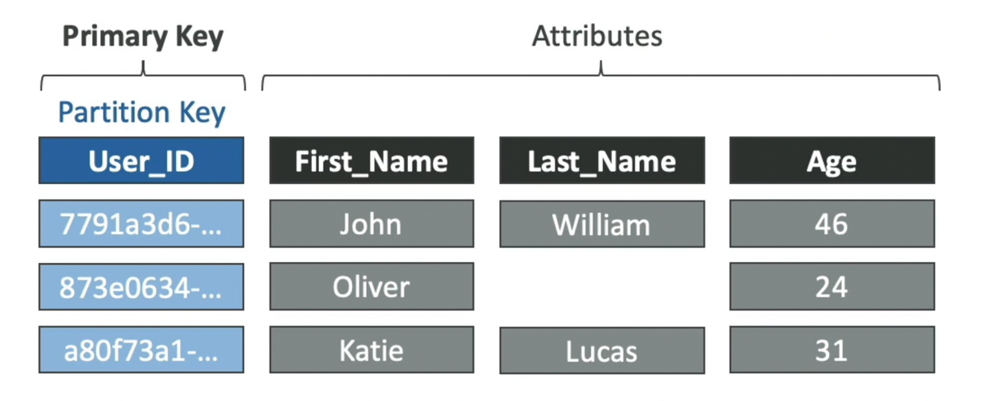

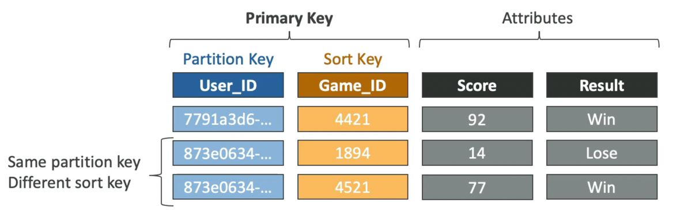

1. Data Types: DynamoDB offers a variety of data types, which can be divided into the following categories:
2. Scalar Types: Number, String, Binary, Boolean and Null
3. Document Types: List and Map
4. Set Types: Number Set, String Set, and Binary Set

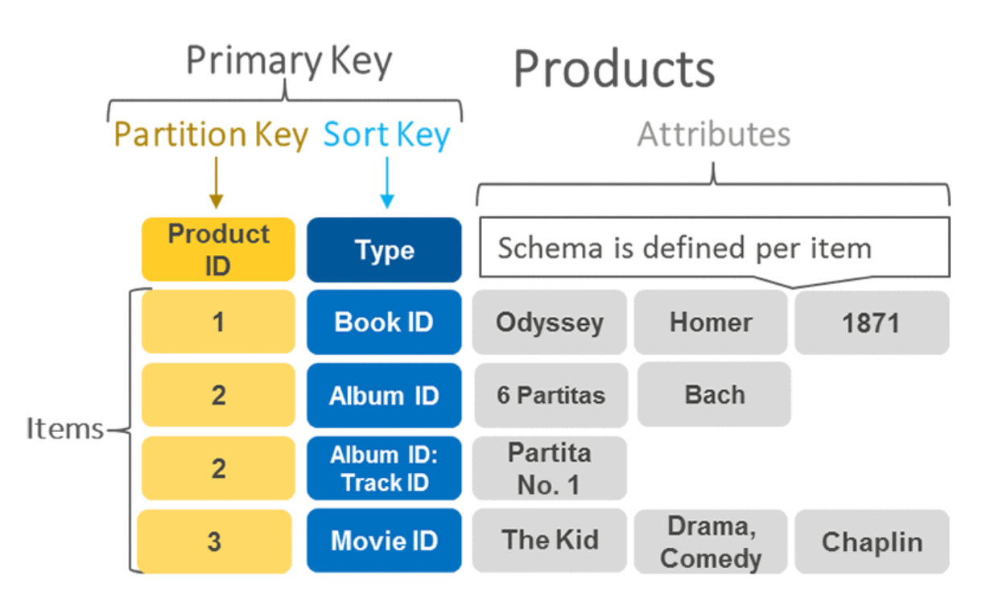

DynamoDB offers two types of indexes which helps in offering access to different query patterns:

1. Local Secondary Index: The same partition key but a different Sort key can be used to construct these. Only when the table is being formed may LSIs be generated. The base table shares capacity units for indexes. LSIs work in both eventual and strong consistency modes.
2. Global Secondary Index: A different partition key and sort key can be used to make these. GSIs can be produced at any time; they are not required to be created at the time of table construction. Although creating GSIs is a time-consuming process, DynamoDB ensures that the underlying table remains accessible while GSIs are being built. As a result, the creation process may take some time. Unlike LSIs, GSIs feature dedicated capacity units. Only consistent reads are supported by GSIs.

**Storage**

* Each physical DynamoDB partition = 10 GB SSD volume
* 1 physical partition can have multiple logical partitions based on partition keys.
* Number of partitions issued is managed internally by DynamoDB.

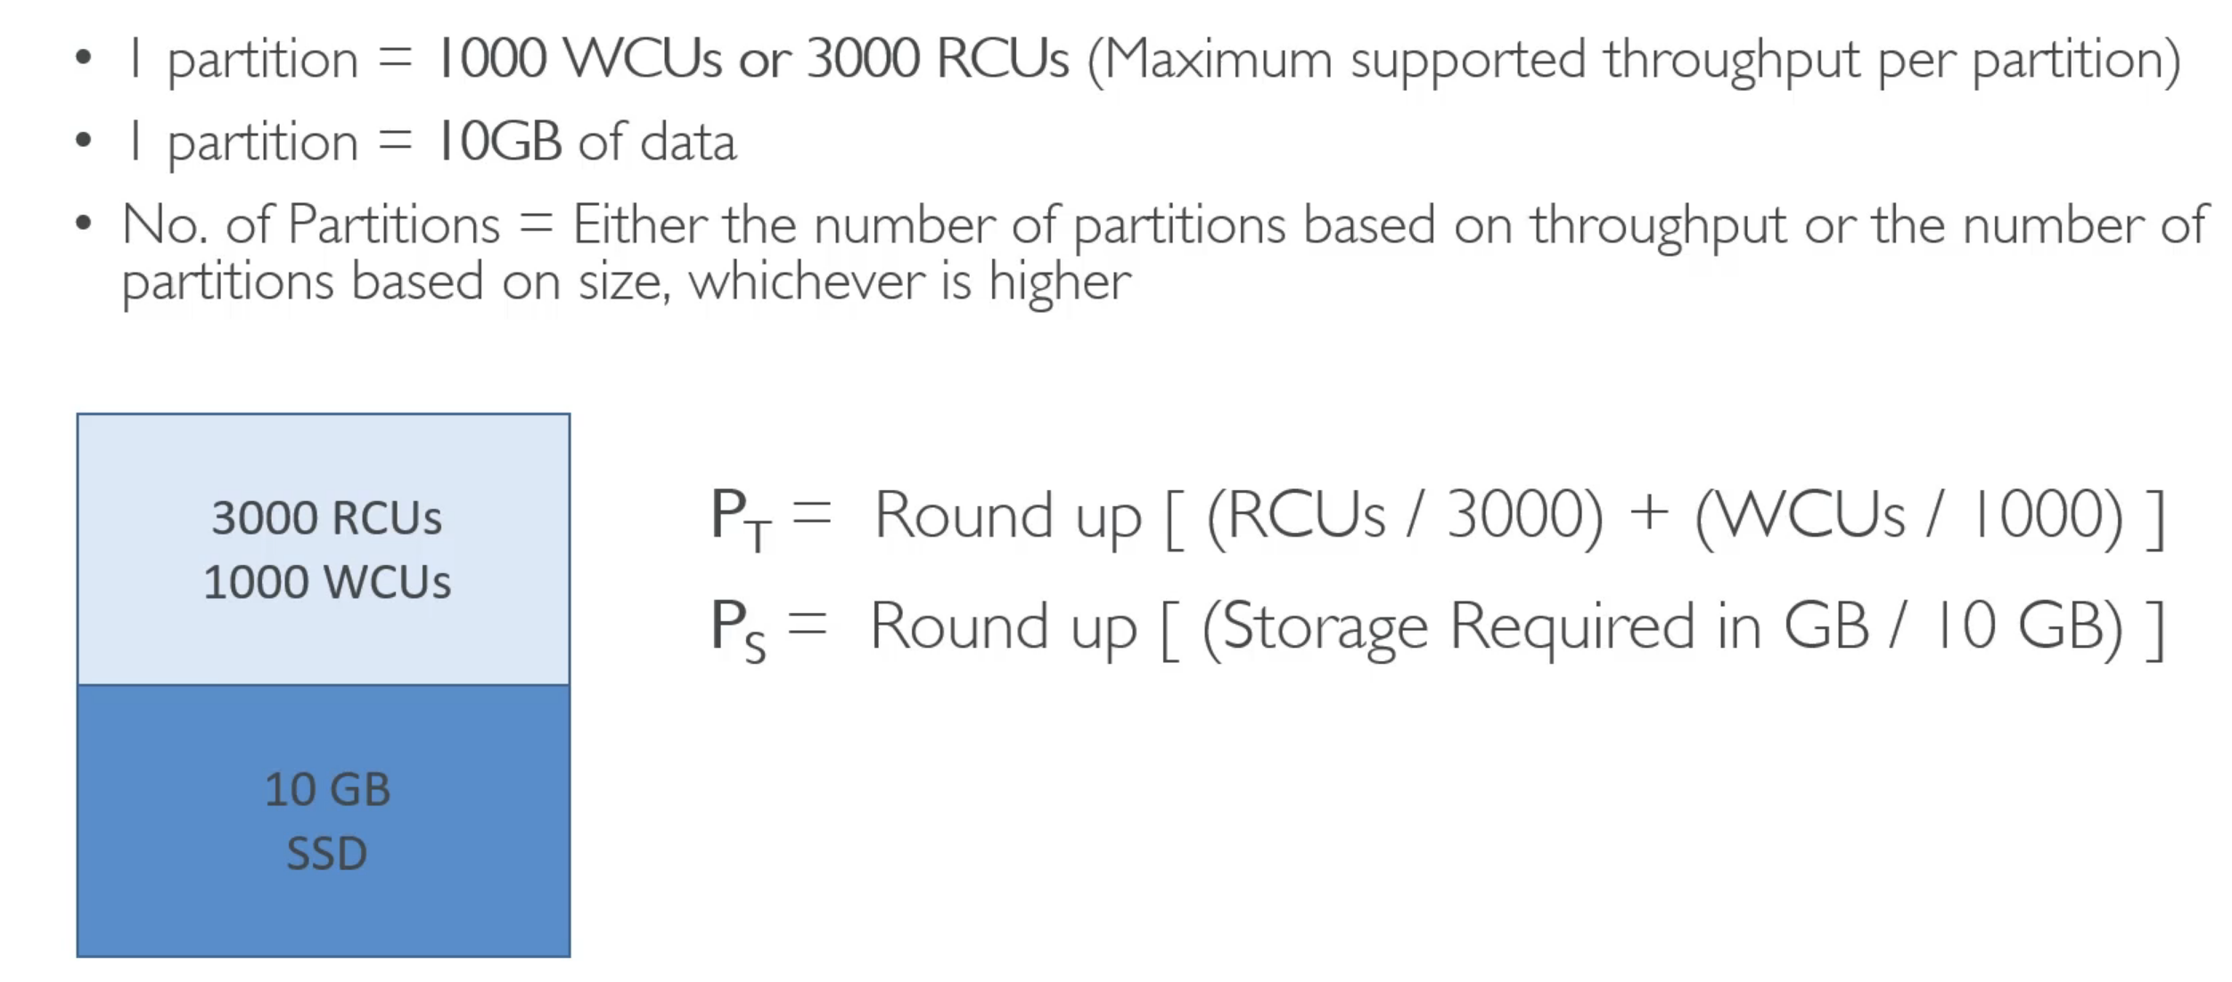

* Auto scaling in DynamoDB can be employed by setting the desired target utilization, minimum and maximum provisioned capacity.

**Top Benefits of Amazon DynamoDB**

The following features and capabilities make DynamoDB an ideal data store service for new apps and small-scale operations that are expected to grow in predictable stages.

1. The advantages of using a fully-managed database service—DynamoDB saves you the costs and labor of setting up your own data operation. The good folks at AWS have already taken care of the hardware provisioning, configuration, and network connectivity. For your convenience, DynamoDB’s features—such as encryption at rest, automatic data replication, cluster scaling, backup and recovery—are built into a user-friendly system. To take full advantage, you should keep up to date with the latest features of Amazon DynamoDB.

2. Linear scalability for growing datasets—DynamoDB uses auto-sharding and load-balancing to help users gain more visibility into how data is stored and distributed. When you can see and control data capacity, you can grow at scale. There’s no data limit, which means that you can continuously expand your data store.

3. Integration with the AWS Ecosystem—DynamoDB was created by AWS and comes integrated with any of the AWS services. You can easily backup data to Amazon Simple Storage Service (Amazon S3), export data and analyze it in Elastic MapReduce (EMR). The AWS Identity and Access Management (IAM) tool gives you controls for securing the connections between the AWS platforms of your choice.

**Appropriate Use Cases**

You should consider using DynamoDB if you:

1. Have had scalability problems with other traditional database systems.
2. Are actively engaged in developing an application or service. It doesn’t always make sense to migrate legacy applications that are not under development, unless you’re willing to invest time and effort to reimplement the data access layer, inline SQL code, or the stored procedures and functions of that application.
3. Are working with an online transaction processing (OLTP) workload. High-performance reads and writes are easy to manage with DynamoDB, and you can expect performance that is effectively constant across widely varying loads.
4. Are deploying a mission-critical application that must be highly available at all times without manual intervention.
5. Are understaffed with respect to management of additional database capability and need to reduce the workload of your operations team.
6. Require a high level of data durability, regardless of your backup-and-restore strategy.
7. Have insufficient data for forecasting peaks and valleys in required database performance.

**Inappropriate Use Cases/ Technical Limitations**

Some unsuitable workloads for DynamoDB include:

1. Services that require ad hoc query access. Though it’s possible to use external relational frameworks to implement entity relationships across DynamoDB tables, these are generally cumbersome.
2. Online analytical processing (OLAP)/data warehouse implementations. These types of applications generally require distribution and the joining of fact and dimension tables that inherently provide a normalized (relational) view of your data.
3. Binary large object (BLOB) storage. DynamoDB can store binary items up to 400 KB, but DynamoDB is not generally suited to storing documents or images. A better architectural pattern for this implementation is to store pointers to Amazon S3 objects in a DynamoDB table.

**Fit to CAP theorem**

According to Eric Brewer’s CAP Theorem (Consistency, Availability, and Partition Tolerance), distributed data stores can’t offer more than two of the three CAP elements simultaneously. The element of consistency ensures that the database remains consistent at all times, availability ensures there are no downtimes, and partition tolerance keeps the system working even if the communication between servers becomes unreliable.

DynamoDB is configured to choose availability and partition tolerance with eventual write consistency. While DynamoDB supports eventually consistent and strongly consistent reads, the latter function can often fail during partitions and network delays. This type of inconsistency is not optimal for global applications.

Additionally, since DynamoDB is set up to provide only consistency and durability, you will need to take care of the rest of the ACID (Atomicity, Consistency, Isolation, Durability) criteria to achieve compliance. To this end, you can use the ACID transactions module at no additional cost.

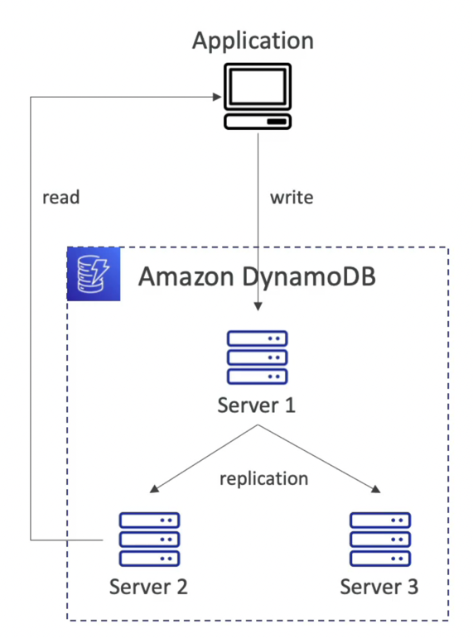

**Competitors**

* Azure Cosmos DB: Azure Cosmos DB provides native support for NoSQL choices, offers multiple well-defined consistency models, guarantees single-digit-millisecond latencies at the 99th percentile, and guarantees high availability with multi-homing capabilities and low latencies anywhere in the world.
* Google Cloud Firestore: Cloud Firestore is a NoSQL document database that lets you easily store, sync, and query data for your mobile and web apps - at global scale.
* Redis: Redis is an open source, advanced key-value store. It is often referred to as a data structure server since keys can contain strings, hashes, lists and sets.
* Couchbase: Couchbase is engineered to meet the elastic scalability, consistent high performance, always-on availability, and data mobility requirements of mission critical applications.
* MongoDB: MongoDB is a database that harnesses the innovations of NoSQL (flexibility, scalability, performance) and builds on the foundation of relational databases (expressive query language, secondary indexes, strong consistency).
* ArangoDB: ArangoDB is a distributed, free, and open-source database with a flexible data model for documents, graphs, and key-values. Build high performance applications using a convenient SQL-like query language or JavaScript extensions.

**Comparision between Amazon DynamoDB vs Azure Cosmos DB**

The following criteria can be used to compare the two most popular NoSQL database services:

Use Cases: CosmosDB incorporates several NoSQL options such as key-value, graph, column family, and document data into a single service, whereas DynamoDB allows all applications to choose between document and key-store models.

Agility: CosmosDB guarantees low latency up to 20 milliseconds for reading and writing data, whereas DynamoDB is a consistent AWS Database service schema with single-digit latency.

Who uses when?: Users with basic use cases and a limited budget should choose CosmoDB, whereas users who do not want their applications to be interrupted or non-elastic should choose DynamoDB.

**DynamoDB Partitions**

So, DynamoDB is made up of tables, each of which has partitions, which are simply copies of our data stored on different servers. When our application writes to DynamoDB, it will send a partition key, maybe a sort key, and some attributes. And all of this information will be subjected to a hashing algorithm. So only the partition key will be subjected to a hashing algorithm in order to choose which partition to use. And this is how our data gets distributed.

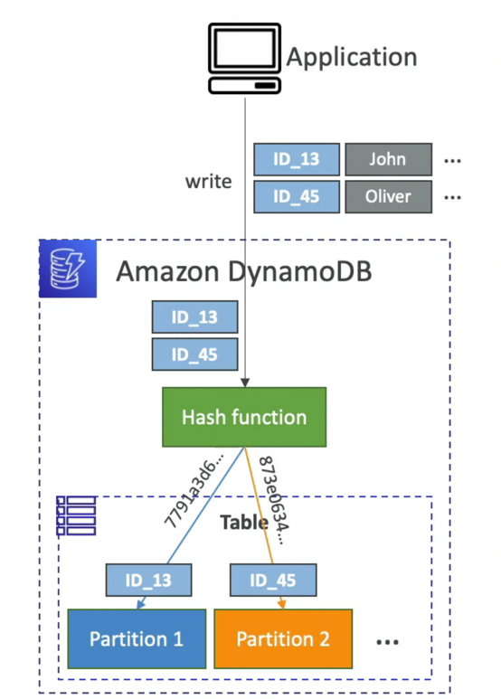

**Querying**

In Amazon DynamoDB, you can use either the DynamoDB API, or PartiQL, a SQL-compatible query language, to query an item from a table. With PartiQL, you can perform a query by using the ExecuteStatement action and the Select statement on the partition key.

With Amazon DynamoDB the Query action lets you retrieve data in a similar fashion. The Query action provides quick, efficient access to the physical locations where the data is stored.

You can use Query with any table that has a composite primary key (partition key and sort key). You must specify an equality condition for the partition key, and you can optionally provide another condition for the sort key.

The KeyConditionExpression parameter specifies the key values that you want to query. You can use an optional FilterExpression to remove certain items from the results before they are returned to you.

In DynamoDB, you must use ExpressionAttributeValues as placeholders in expression parameters (such as KeyConditionExpression and FilterExpression). This is analogous to the use of bind variables in relational databases, where you substitute the actual values into the SELECT statement at runtime.

**Demo**

1. **Bulk data ingestion from S3 into DynamoDB via AWS Lambda:**

The following steps were performed to load the data from S3 into DynamoDB via AWS Lambda.

1. Create a bucket in S3 and upload the data. The data we chose here is the dataset of electric vehicles.
2. Create an IAM role with required permissions.
3. Configure a Lambda function.
4. Add code into Lambda function.

**Update Data into S3**: We started by creating an S3 bucket and then uploading our CSV file to it. This can be done programmatically or using the AWS console. With the relevant IAM policy connected, the Lambda function will programmatically access the bucket contents.

test-electricv is the bucket created in S3 and ElectricCarData_Clean. Csv is our csv file loaded onto test-electric bucket. 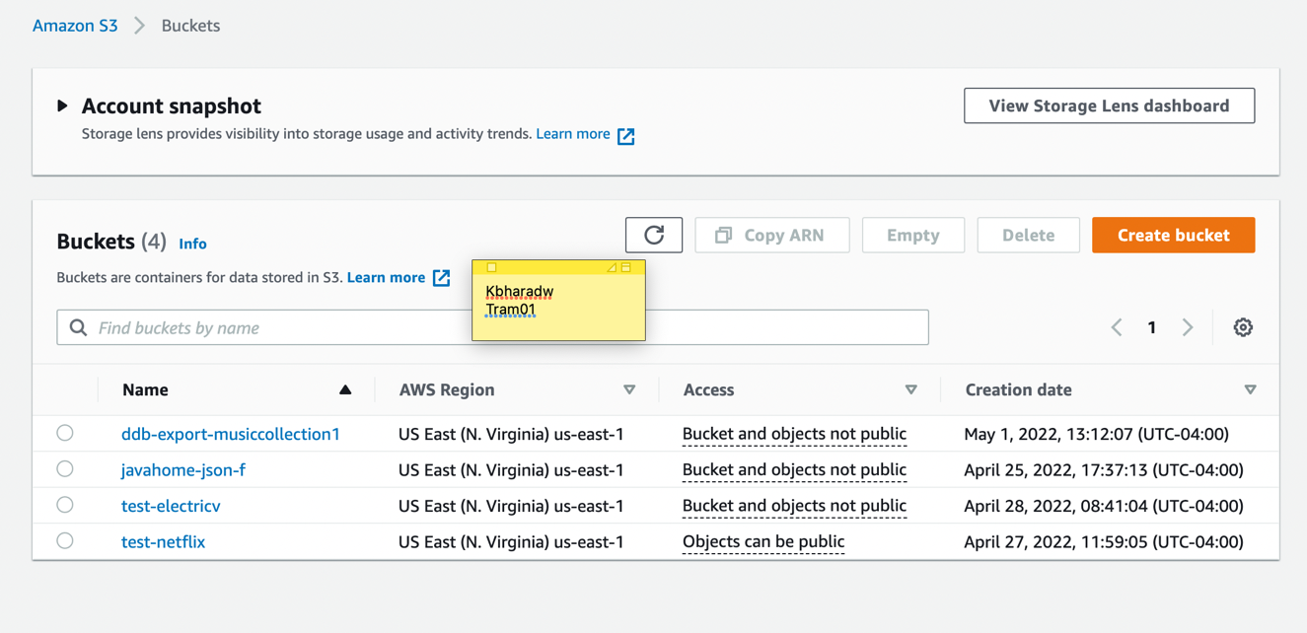

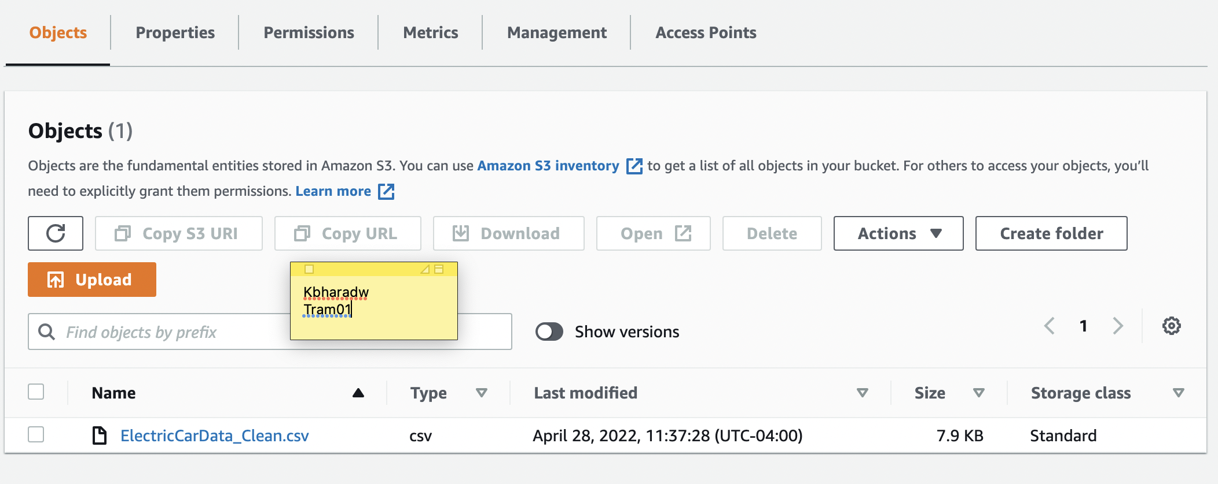

**IAM policy with S3 and DynamoDB access**: We created an IAM Role with the necessary rights to access our S3 bucket and DynamoDB tables. For our purposes, the two Amazon-managed policies are AmazonS3FullAccess and AmazonDynamoDBFullAccess.

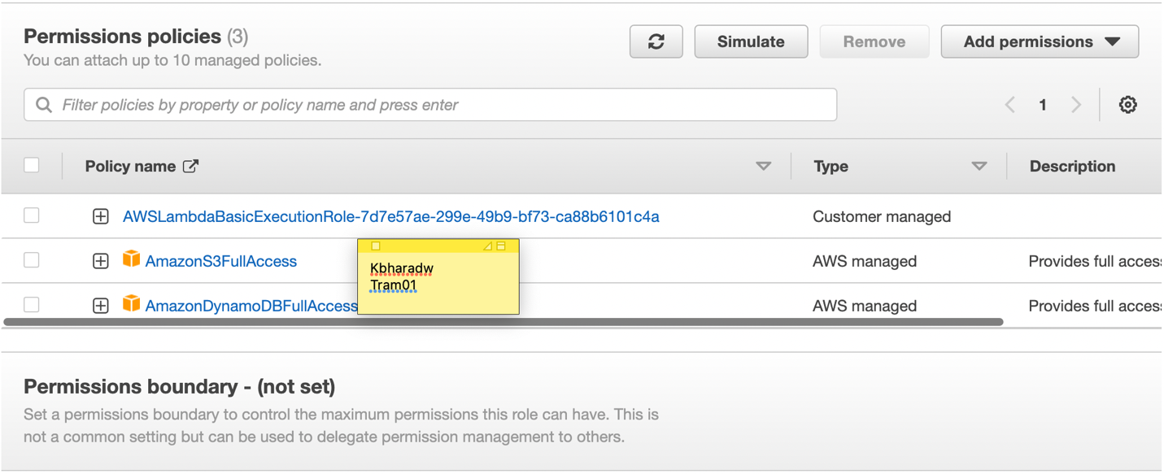

**Create a Lambda function:** Now that we have our data and permissions in place, we can develop a Lambda function to read data from S3 and ingest it into our DynamoDB table. The most important step here is to link the IAM role we defined earlier to our Lambda function in the permissions section. This would allow our lambda function code to programmatically access both S3 and DynamoDB. Here, electricvehicles is the function created.

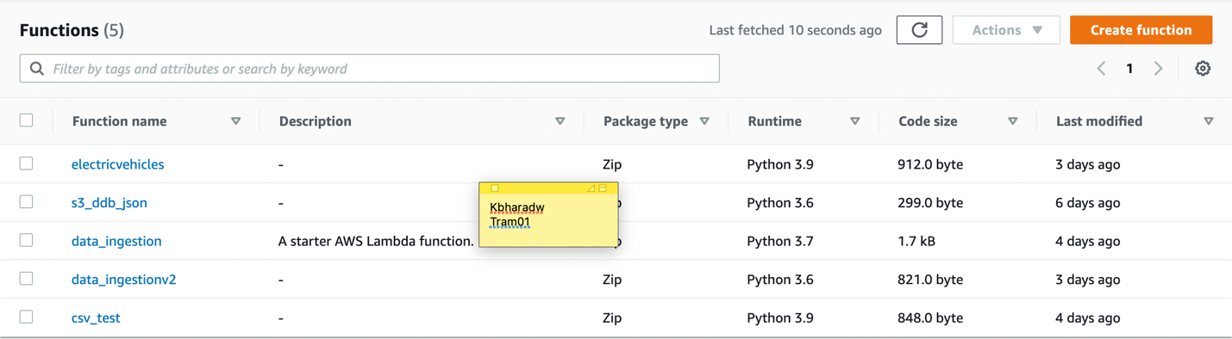

We used the boto3 resource API to write the python code to load the service instance object. The metadata of the file is passed using an event object (S3 bucket, filename). The S3 file data was then loaded into the JSON object using S3 client action methods. After parsing the JSON data, we saved it to a DyanamoDB table.

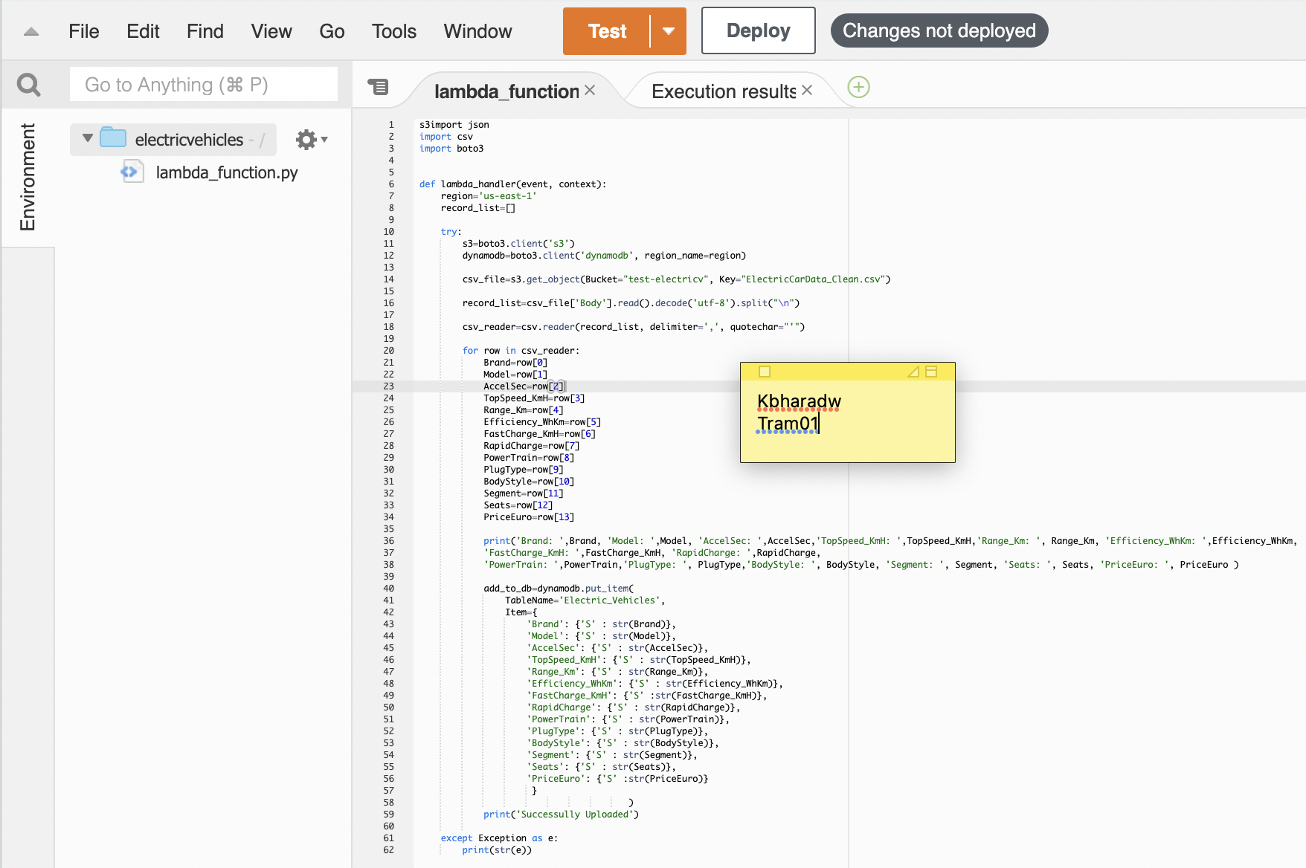

We now have our csv file content in the Electric_Vehicles table in DynamoDB.

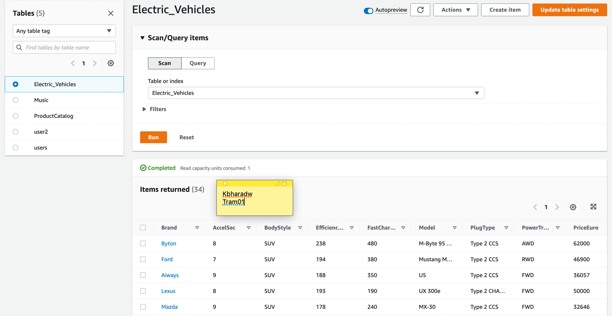

1. **Creating a table using AWS console**

We also create tables using DynamoDB console to show some DynamoDB table properties. It is completely fine to add attributes overtime. We can add attributes over time without impacting our previous data. The only thing that has to be non-null is the primary key.

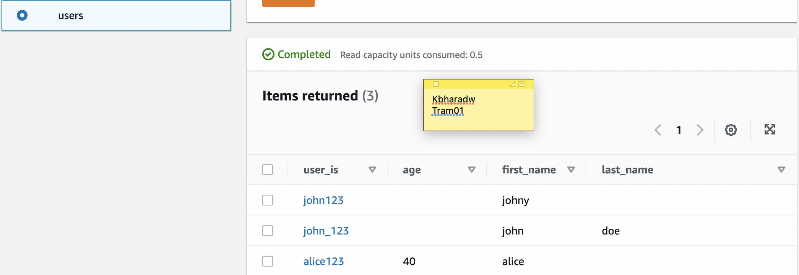

1. **Create and query tables using AWS CLI**

In this section, we use the DynamoDB API and PartiQL for DynamoDB from the AWS CLI to create and query a table in DynamoDB.

1. **Create a table:**

We will create a Music table in Amazon DynamoDB in this step. The following details can be found in the table:

* Partition Key – Artist
* Sort Key – Song Title

Create-table is used in the following AWS CLI example to create a new Music table.

aws dynamodb create-table \

--table-name Music \

--attribute-definitions \

AttributeName=Artist,AttributeType=S \

AttributeName=SongTitle,AttributeType=S \

--key-schema \

AttributeName=Artist,KeyType=HASH \

AttributeName=SongTitle,KeyType=RANGE \

--provisioned-throughput \

ReadCapacityUnits=5,WriteCapacityUnits=5 \

--table-class STANDARD

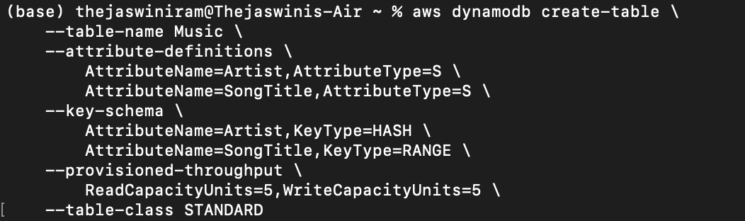

The following is the result obtained by using create-table:

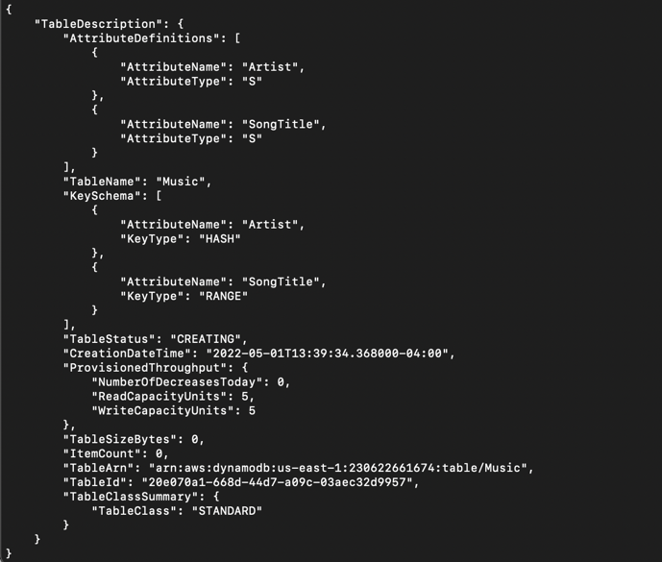

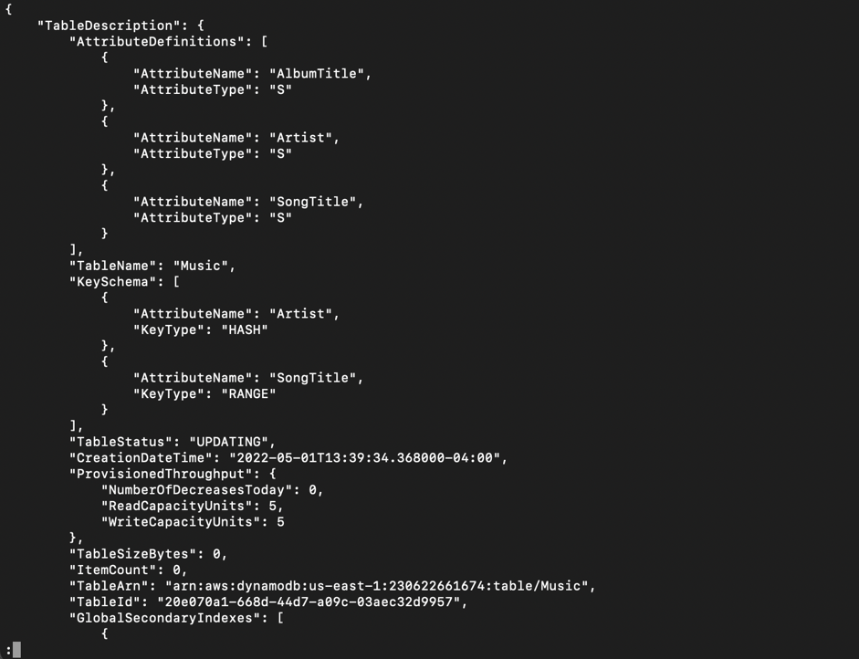

It's important to note that the TableStatus field is set to CREATING.

Use the describe-table command to see if DynamoDB has finished generating the Music table.

aws dynamodb describe-table --table-name Music | grep TableStatus



The following is the output of this command. The value of the TableStatus field is set to ACTIVE when DynamoDB finishes constructing the table.

"TableStatus": "ACTIVE",

1. **Write Data:**

In this step, we insert several items into the Music table that we created in the step 1.

The AWS CLI example below adds a few extra items to the Music table. We can do this using the DynamoDB API or PartiQL, a SQL-compatible DynamoDB query language.

aws dynamodb put-item \

--table-name Music \

--item \

'{"Artist": {"S": "No One You Know"}, "SongTitle": {"S": "Call Me Today"}, "AlbumTitle": {"S": "Somewhat Famous"}, "Awards": {"N": "1"}}'

aws dynamodb put-item \

--table-name Music \

--item \

'{"Artist": {"S": "No One You Know"}, "SongTitle": {"S": "Howdy"}, "AlbumTitle": {"S": "Somewhat Famous"}, "Awards": {"N": "2"}}'

aws dynamodb put-item \

--table-name Music \

--item \

'{"Artist": {"S": "Acme Band"}, "SongTitle": {"S": "Happy Day"}, "AlbumTitle": {"S": "Songs About Life"}, "Awards": {"N": "10"} }'

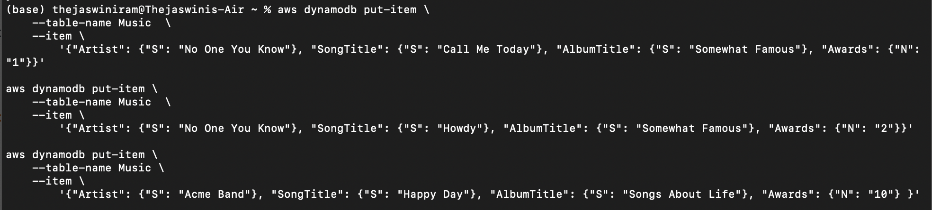

aws dynamodb execute-statement --statement "INSERT INTO Music \

VALUE \

{'Artist':'Acme Band','SongTitle':'PartiQL Rocks', 'AlbumTitle':'Another Album Title', 'Awards':'8'}"

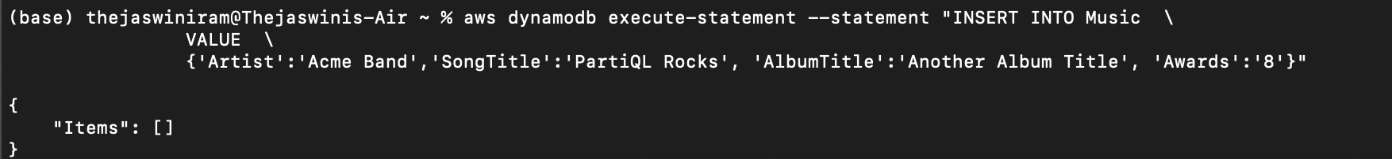

1. **Read data from a table:**

Using the Console or the AWS CLI, we'll read back an item created in Step 2 in this step. By specifying Artist and SongTitle, we may read an item from the Music table using the DynamoDB console or the AWS CLI.

The AWS CLI example below reads an item from the Music folder. We can do this using the DynamoDB API or PartiQL, a SQL-compatible DynamoDB query language.

aws dynamodb get-item --consistent-read \

--table-name Music \

--key '{ "Artist": {"S": "Acme Band"}, "SongTitle": {"S": "Happy Day"}}'

The following is an example of what get-item returns.

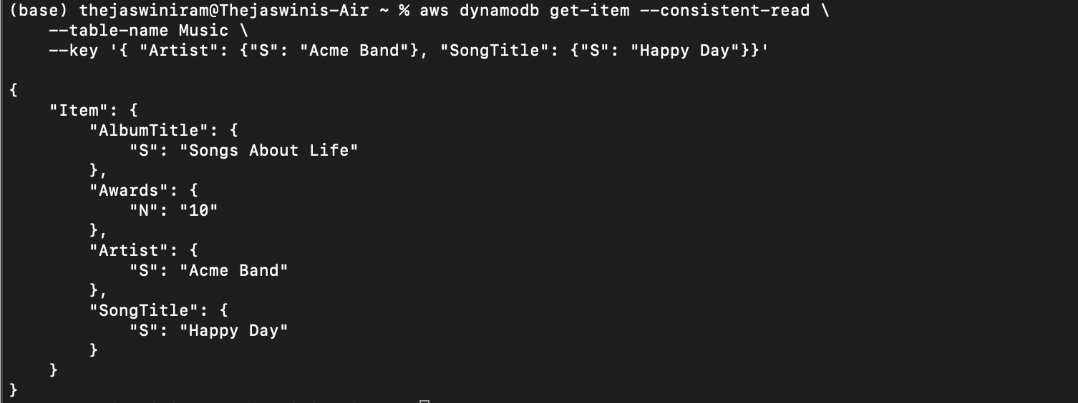

aws dynamodb execute-statement --statement "SELECT * FROM Music \

WHERE Artist='Acme Band' AND SongTitle='Happy Day'"

The following is the PartiQL Select statement result.

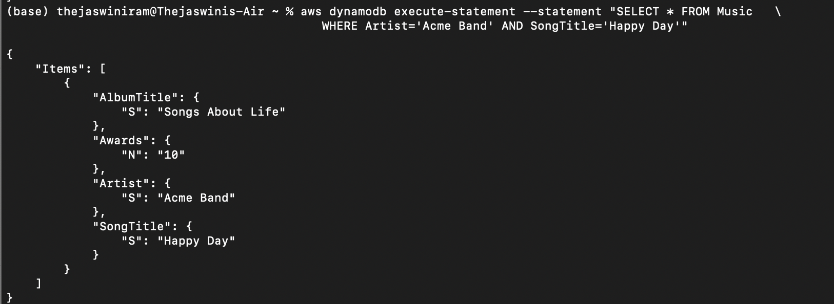

1. **Update Data in a Table:**

Using the Console or the AWS CLI, we update an item created in Step 2 in this step. By supplying Artist, SongTitle, and the revised AlbumTitle, we may update the AlbumTitle of an item in the Music database using the DynamoDB console or the AWS CLI.

The following AWS CLI example updates a Music table item. We have done this using the DynamoDB API and PartiQL, a SQL-compatible DynamoDB query language.

aws dynamodb update-item \

--table-name Music \

--key '{ "Artist": {"S": "Acme Band"}, "SongTitle": {"S": "Happy Day"}}' \

--update-expression "SET AlbumTitle = :newval" \

--expression-attribute-values '{":newval":{"S":"Updated Album Title"}}' \

--return-values ALL_NEW

Because return-values ALL NEW was given, update-item provides the following result.

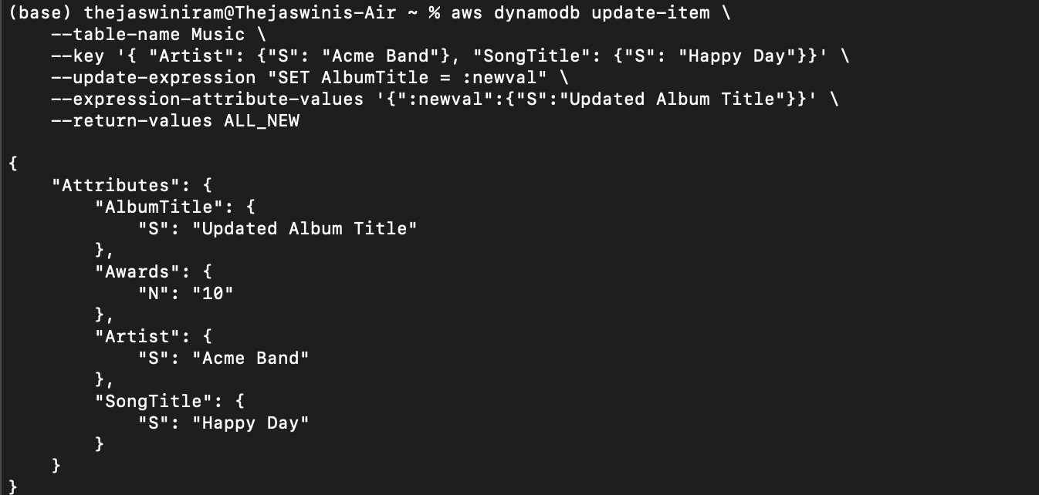

aws dynamodb execute-statement --statement "UPDATE Music \

SET AlbumTitle='Updated Album Title' \

WHERE Artist='Acme Band' AND SongTitle='Happy Day' \

RETURNING ALL NEW *"

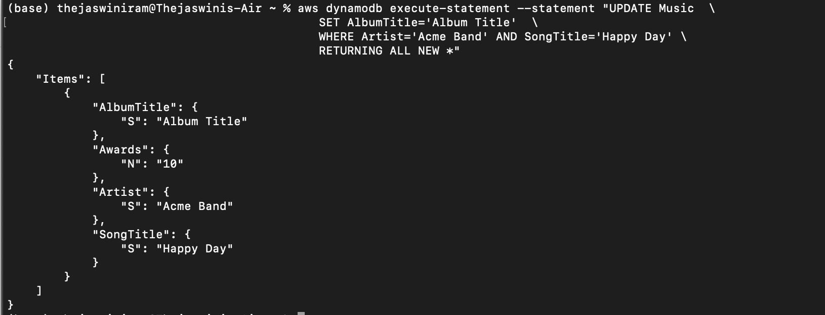

1. **Query Data:**

We query the data that we wrote to the Music database in Step 2 in this step: By specifying Artist in the Console or AWS CLI, we can write data to a table. This will show you all of the songs that are linked to the partition key: Artist.

aws dynamodb query \

--table-name Music \

--key-condition-expression "Artist = :name" \

--expression-attribute-values '{":name":{"S":"Acme Band"}}'

Using this query, all of the songs linked with this Artist will be returned.

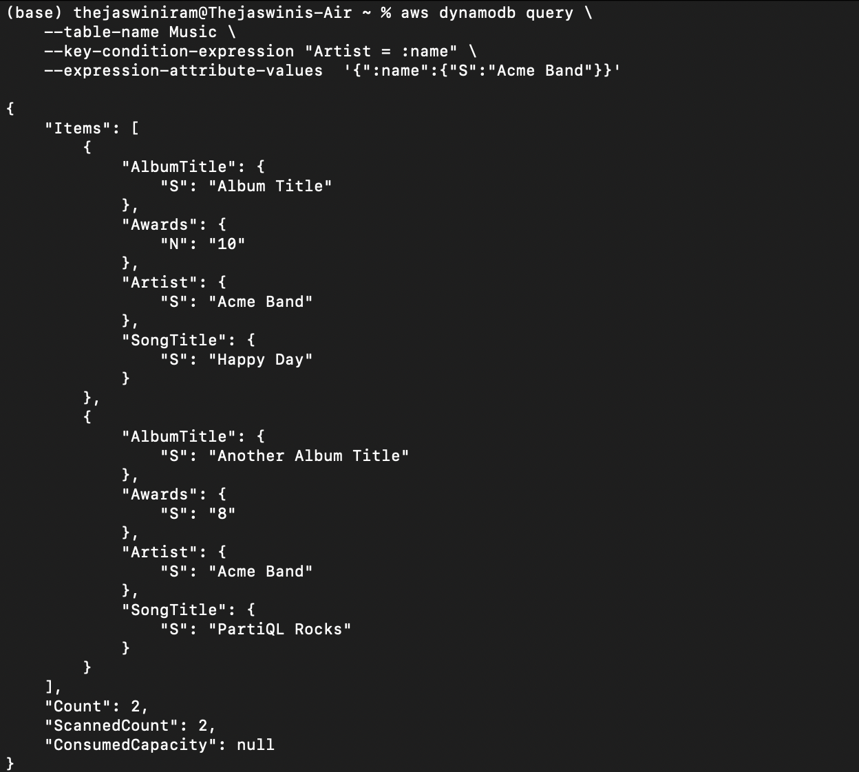

Using the Select statement and the partition key, we can query an item in PartiQL.

aws dynamodb execute-statement --statement "SELECT * FROM Music \

WHERE Artist='Acme Band'"

This use of the Select statement returns all of the songs linked with this Artist.

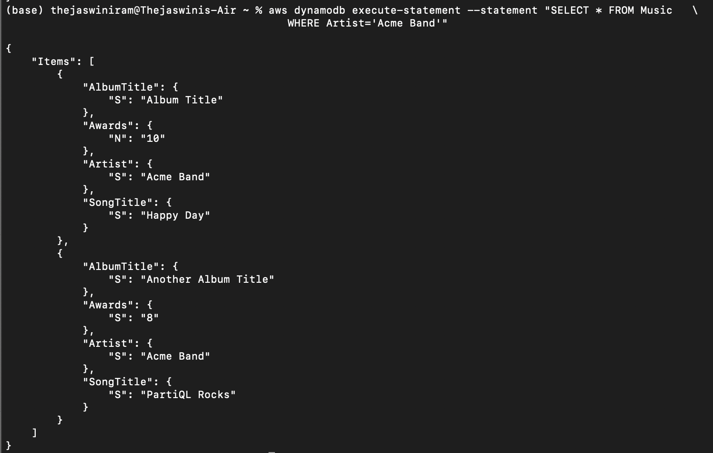

1. **Create a Global Secondary Index**

We built a global secondary index for the Music table we generated in Step 1 in this step

Using update-table, the following AWS CLI example builds a global secondary index AlbumTitle-index for the Music table.

aws dynamodb update-table \

--table-name Music \

--attribute-definitions AttributeName=AlbumTitle,AttributeType=S \

--global-secondary-index-updates \

"[{\"Create\":{\"IndexName\": \"AlbumTitle-index\",\"KeySchema\":[{\"AttributeName\":\"AlbumTitle\",\"KeyType\":\"HASH\"}], \

\"ProvisionedThroughput\": {\"ReadCapacityUnits\": 10, \"WriteCapacityUnits\": 5 },\"Projection\":{\"ProjectionType\":\"ALL\"}}}]"

The following result was obtained by using update-table.

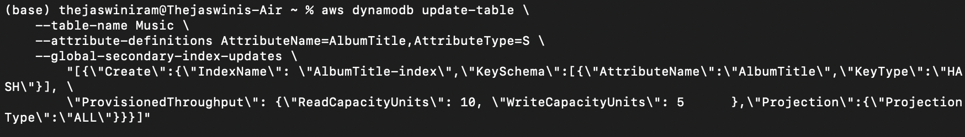

1. **Query the Global Secondary Index**

We use the DynamoDB API to query the global secondary index by using query and supplying the index name.

aws dynamodb query \

--table-name Music \

--index-name AlbumTitle-index \

--key-condition-expression "AlbumTitle = :name" \

--expression-attribute-values '{":name":{"S":"Somewhat Famous"}}'

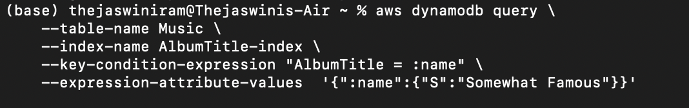

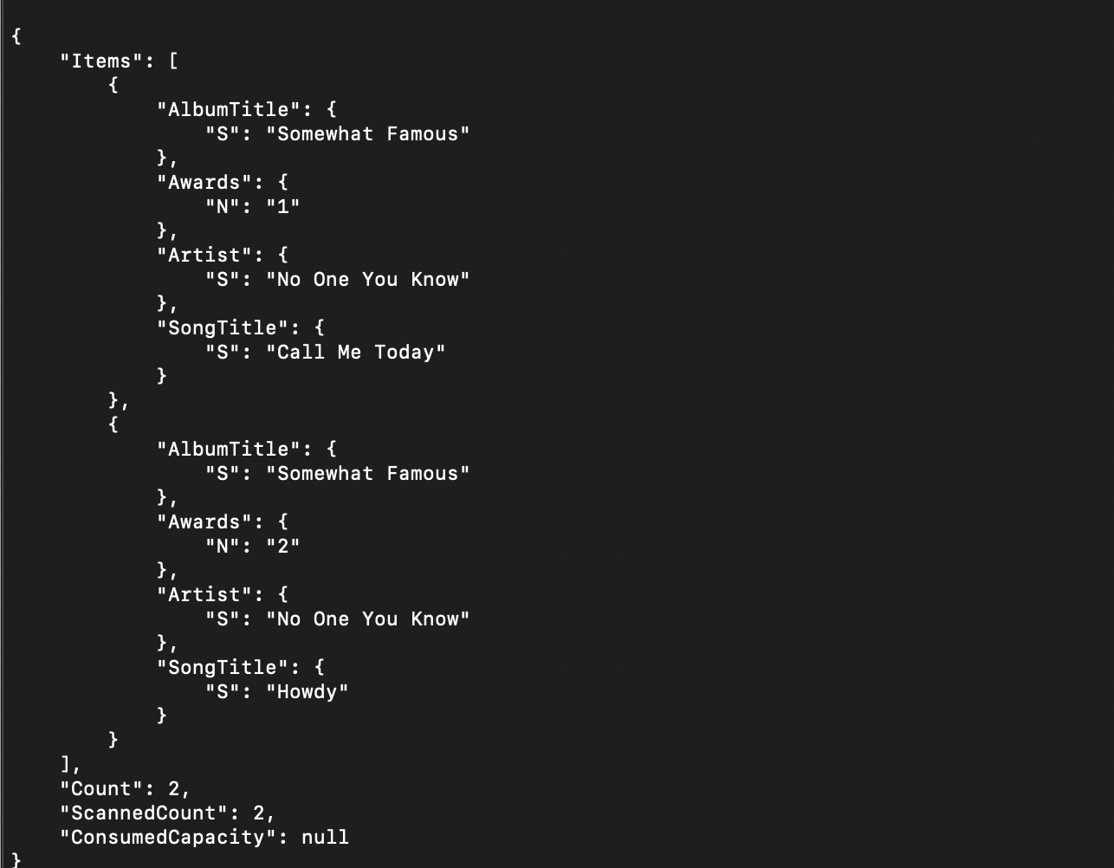

1. **Export Table:**

DynamoDB table exports allow us to export table data to an Amazon S3 bucket, allowing users to use other AWS services like Athena, AWS Glue, and Lake Formation to do analytics and complicated queries on our data. We can use the AWS Management Console, the AWS CLI, or the DynamoDB API to request a table export.

aws dynamodb update-continuous-backups \

--table-name Music\

--point-in-time-recovery-specification PointInTimeRecoveryEnabled=True

aws dynamodb export-table-to-point-in-time \

--table-arn arn:aws:dynamodb:us-east-1:230622661674:table/Music \

--s3-bucket ddb-export-musiccollection1 \

--export-format DYNAMODB_JSON \

--s3-sse-algorithm AES256

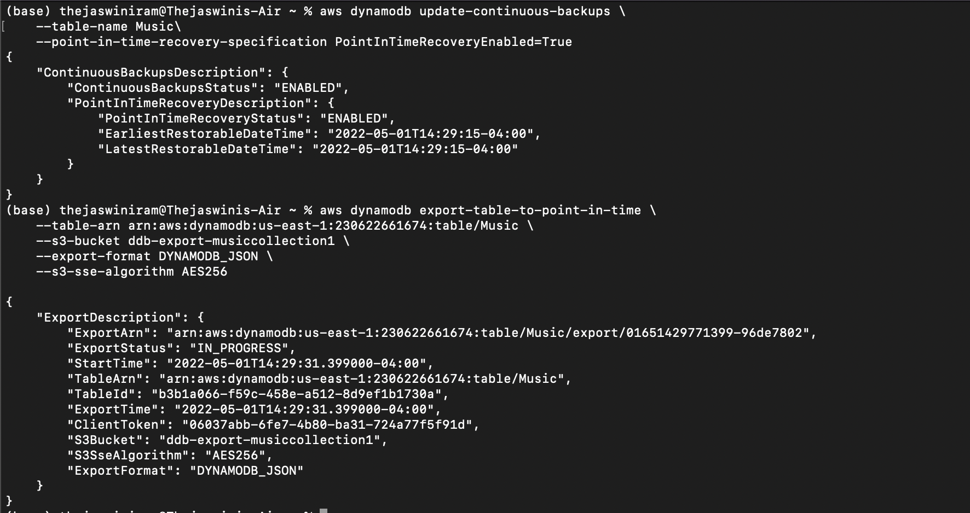

**References**

* <https://hevodata.com/learn/boto3-lambda/>
* <https://blog.yugabyte.com/11-things-you-wish-you-knew-before-starting-with-dynamodb/>
* <https://db-engines.com/en/system/Amazon+DynamoDB%3BMicrosoft+Azure+Cosmos+DB>
* <https://docs.aws.amazon.com/amazondynamodb/latest/developerguide/ql-gettingstarted.html>
* <https://docs.aws.amazon.com/amazondynamodb/latest/developerguide/ql-gettingstarted.html>
* <https://www.udemy.com/share/1044by3@MiI1tWnjB4EtKAPCkVq-f3vUUWi-4NXay3SEp20DqJSY_cXSzOUtX1rhHj4tDc5fbQ==/>
* <https://www.udemy.com/share/1044by3@MiI1tWnjB4EtKAPCkVq-f3vUUWi-4NXay3SEp20DqJSY_cXSzOUtX1rhHj4tDc5fbQ==/>